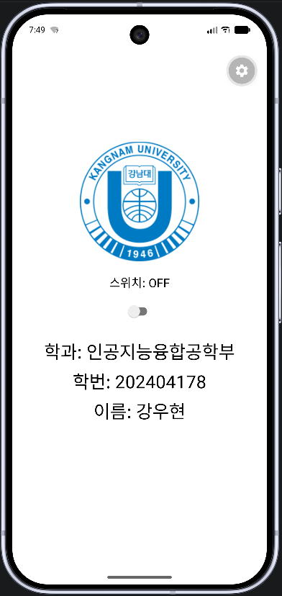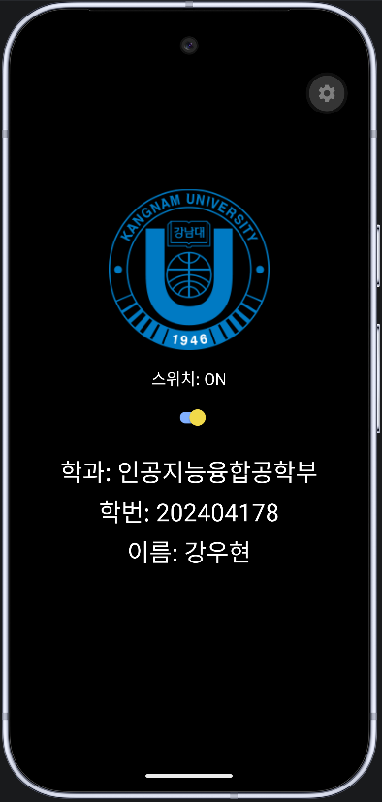

import React, { useState } from 'react';
import { View, Text, Image, Switch, StyleSheet } from 'react-native';
const DEPARTMENT = '인공지능융합공학부';
const STUDENT_ID = '202404178';
const NAME = '강우현';
export default function App() {
const [darkMode, setDarkMode] = useState(false);
const textColor = { color: darkMode ? 'white' : 'black' };
return (
<View
style={[
styles.container,
{ backgroundColor: darkMode ? 'black' : 'white' },
]}
>
<View style={styles.top}>
<Image source={require('./assets/logo.png')} style={styles.image} />
</View>
<View style={styles.center}>
<Text style={[styles.switchText, textColor]}>
{darkMode ? '스위치: ON' : '스위치: OFF'}
</Text>
<Switch
value={darkMode}
onValueChange={setDarkMode}
trackColor={{ false: '#767577', true: '#81b0ff' }}
thumbColor={darkMode ? '#f5dd4b' : '#f4f3f4'}
/>
</View>
<View style={styles.bottom}>
<Text style={[styles.info, textColor]}>학과: {DEPARTMENT}</Text>
<Text style={[styles.info, textColor]}>학번: {STUDENT_ID}</Text>
<Text style={[styles.info, textColor]}>이름: {NAME}</Text>
</View>
</View>
);
}
const styles = StyleSheet.create({
container: { flex: 1 },
top: { flex: 1, justifyContent: 'flex-end', alignItems: 'center', paddingBottom: 20 },
center: { alignItems: 'center' },
bottom: { flex: 1, justifyContent: 'flex-start', alignItems: 'center', paddingTop: 20 },
image: { width: 200, height: 200 },
switchText: { fontSize: 20, marginBottom: 10 },
info: { fontSize: 30, marginBottom: 6 },
});

